**PROJECT REPORT**

PROJECT NAME: \

**SSNAKE GAME**

MEMBERS NAME:

**MEHRIIN SHEIKH 11407**

**MAHADEV KHATRI 11310**

**HARIS AHMED 11269**

DATE:

**H19 – APRIL – 2021**

**PROJECT DESCRIPTION:**

In the game of Snake, the player uses the arrow keys to move a "snake" around the board. As the snake finds food, it eats the food, and thereby grows larger. The game ends when the snake either moves off the screen or moves into itself. The goal is to make the snake as large as possible before that happens. So basically, In this game you first have to start the game you will find a circle and a static red circle which is snake’s food. By the moving the red circle you have to pass the snake. If you do this then you will get a one point and another static red circle generated at another location. And you have to repeat it again. To win this game you have to get max points. You can control the snake by up, down, left and right arrow. If moving snake touches the boundary then your game will be over so be careful about that. You can restart the game by clicking on restart. When you play the game the next time it starts from the start. All these things are managed by your profile. Here, no concept of database. It handles the profile just from the simple text files.

**CASES USED IN THIS PROJECT:**

The cases we used in this game is SWITCH case. This case moves rest of the body according to which way the head is moving.

**WHAT WE WANT TO MAKE:**

Snake game.

**FEATURES:**

The main feature this program includes this when the snake touches the wall or itself, the game ends.

**HOW THE PROJECT IS IMPLEMENTED:**

1. We have added the GUI components for this game.
2. We have added the events for this game.
3. We have created 3 external classes Settings, Input and Circle.
4. We added custom events to the Form1.CS file.
5. We have created custom functions eat(), die(), movePlayer(), generateFood() and startGame().

**HOW MUCH TIME IT TOOK TO MAKE PROJECT:**

4 months.

**PROJECT LIMITATIONS:**

User has to play full concentration or else he will fail whenever snake touches the wall and body.

**PROBLEMS FACED DURIND THE PROJECT:**

Hashtag was new to us as we had never study about it and we have to do and find it on our own. Secondly list, as we had never look up on it.

**GUI:**

It has good GUI.

**REAL-LIFE EXAMPLE:**

It does not use or work in real life example as snake does not die whenever it touches any wall or snake.

**SCREEN SHOTS:**

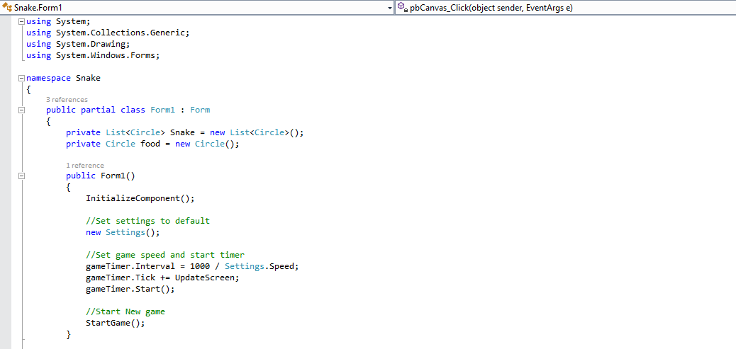

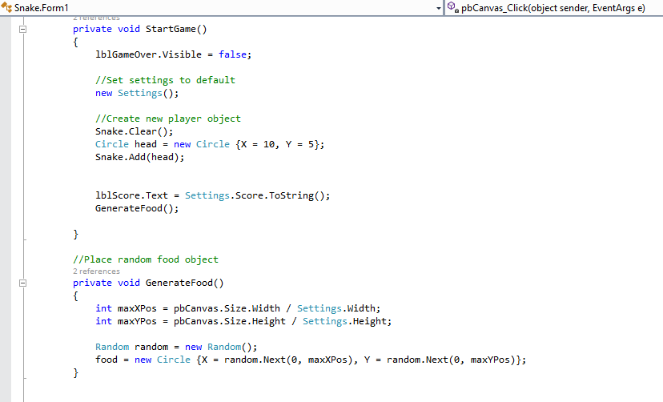

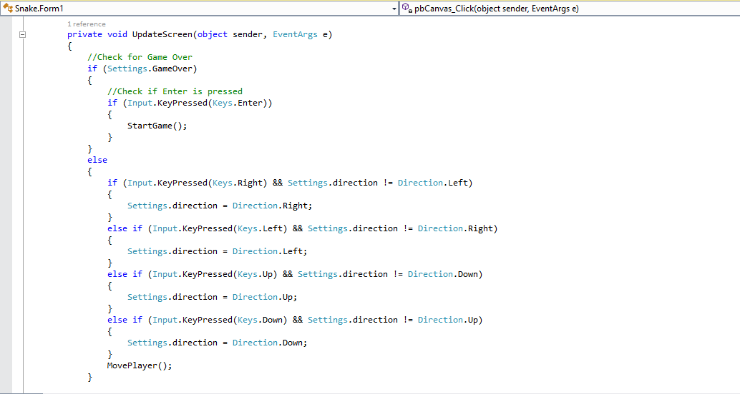

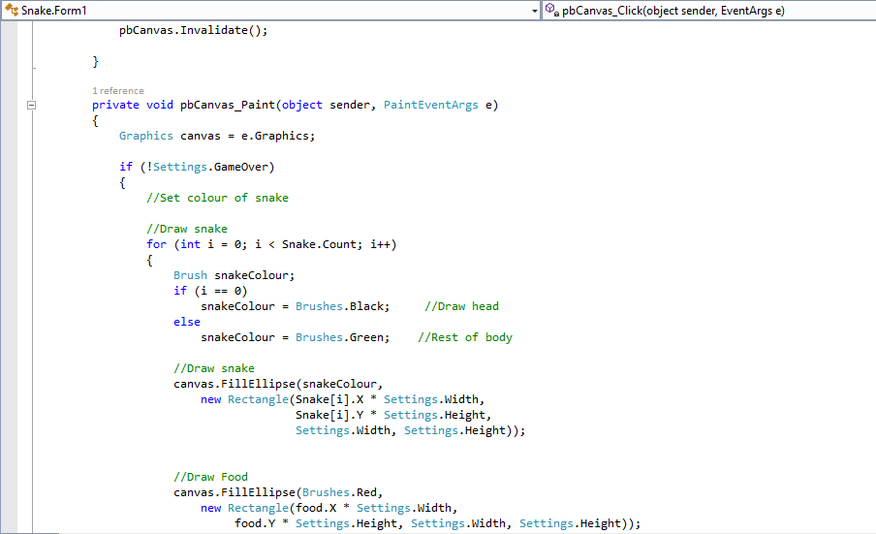

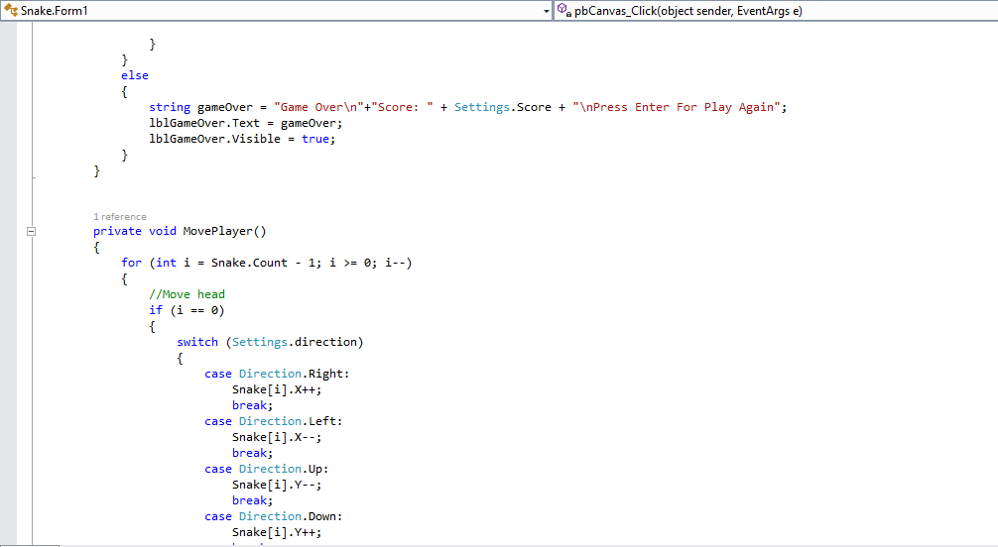

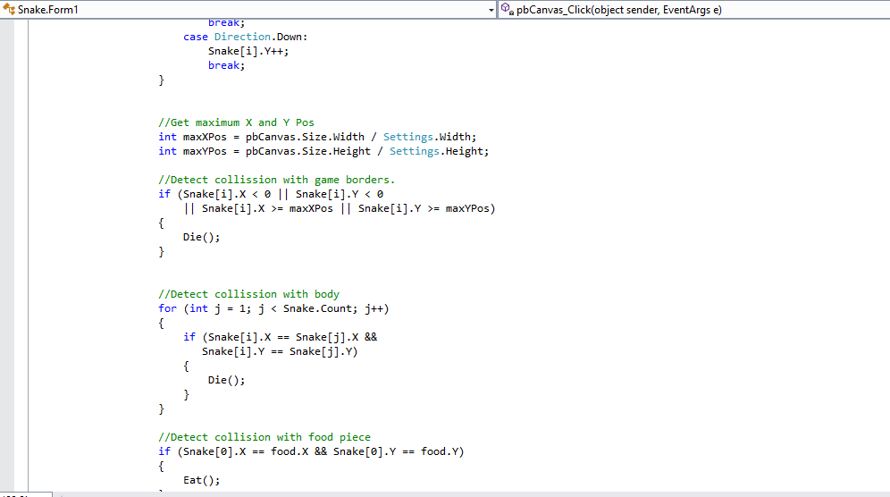

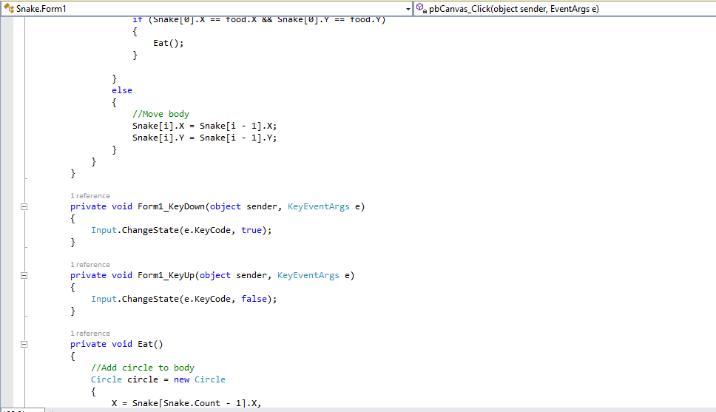

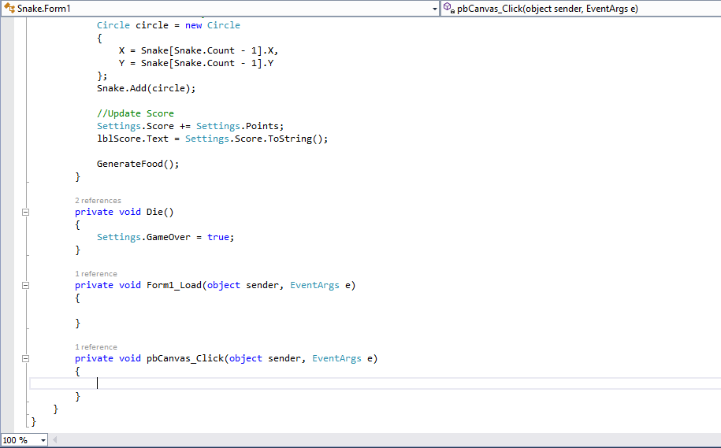

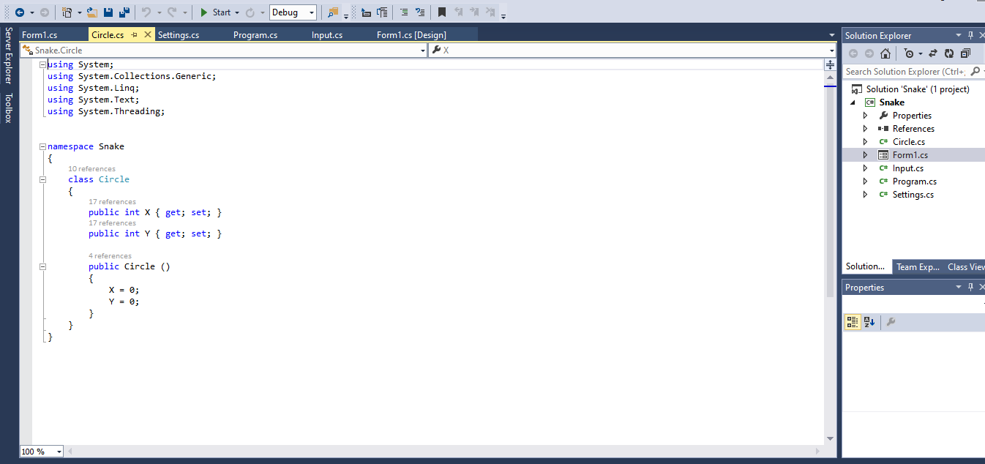

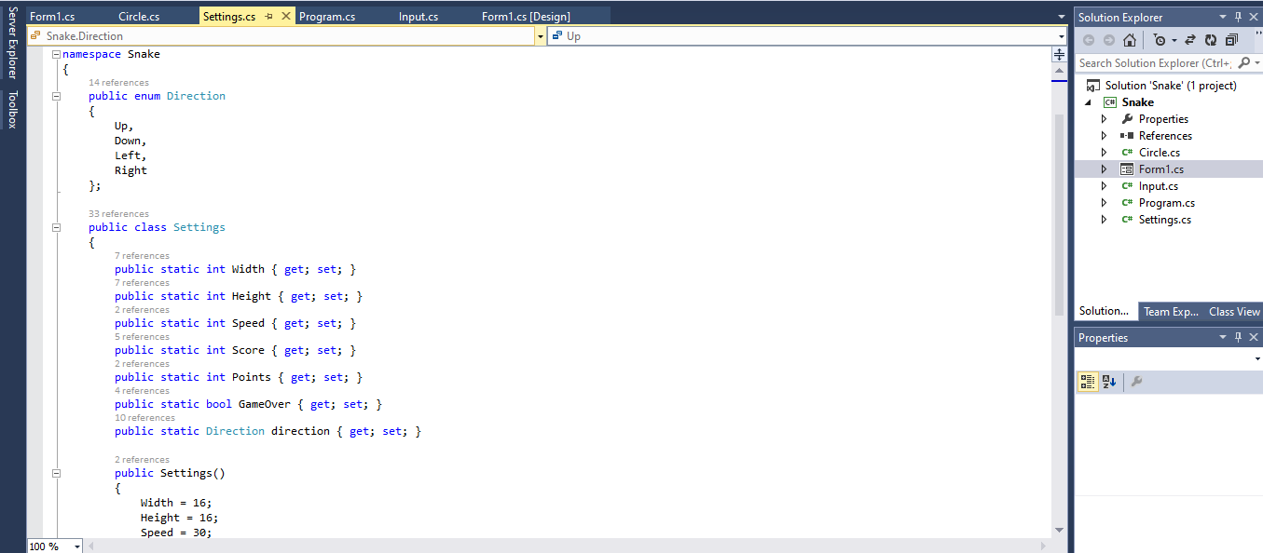

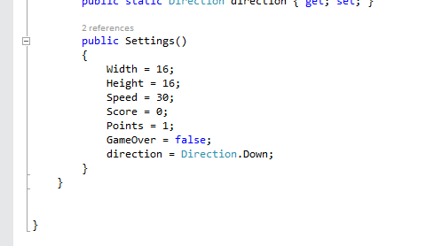

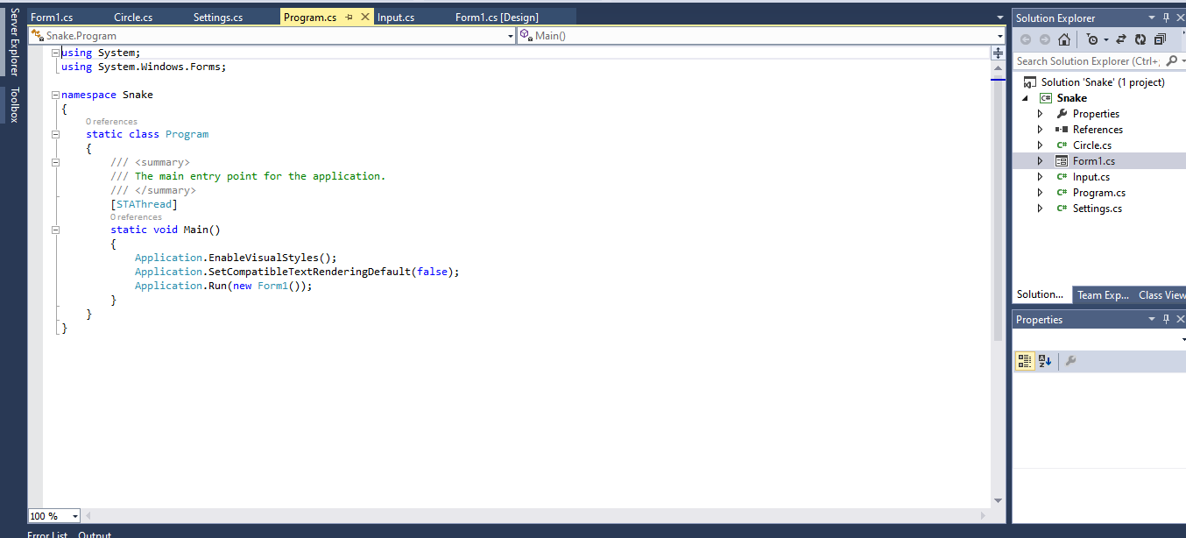

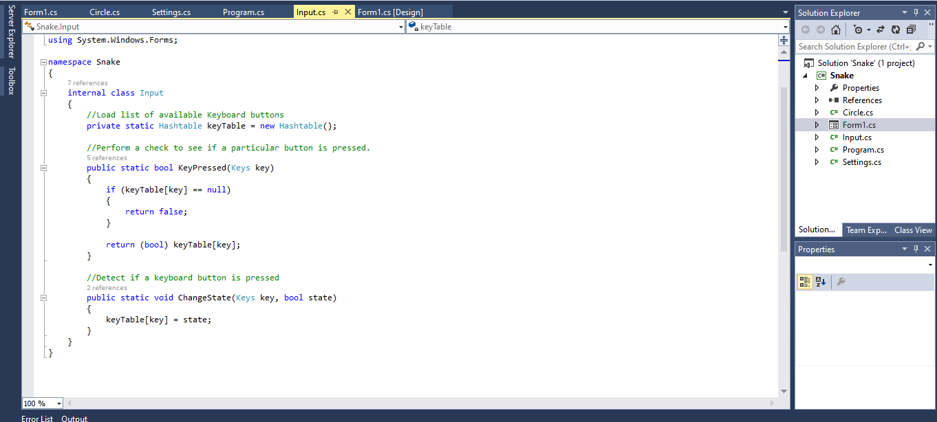

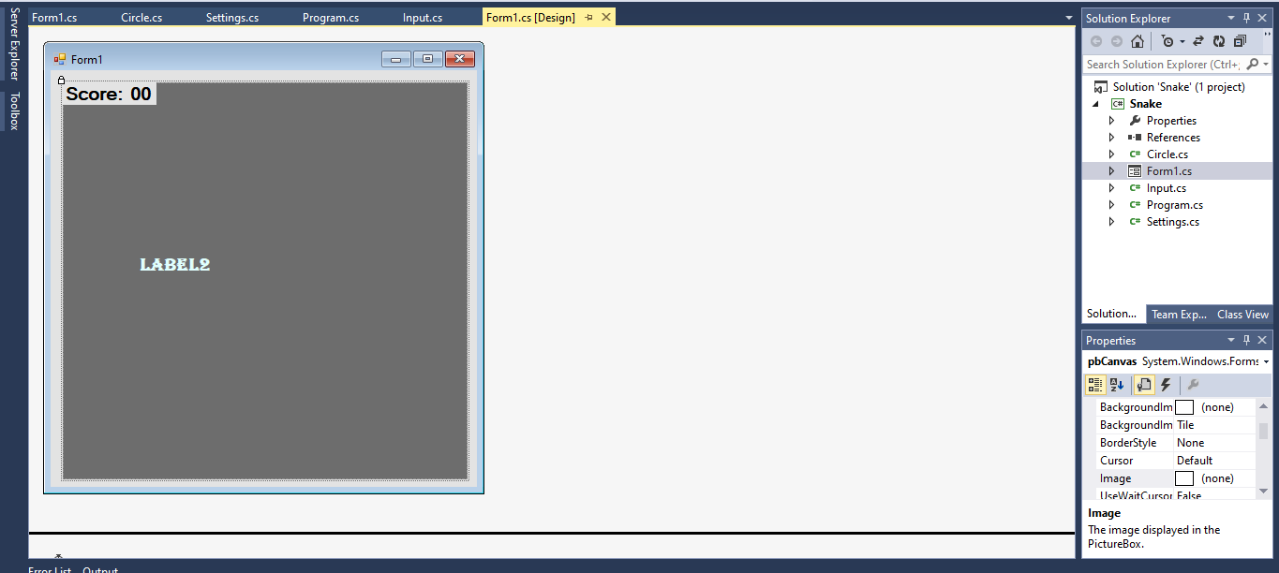

**REFERENCE:**

Internet.